**Artificial Intelligence for Dynamic Monitoring and Prediction of Low Anterior Resection Syndrome (LARS) via a Digital Health Platform: A Multi-Center Pilot Study**

Artificial Intelligence (AI) combined with patient-reported data via mobile health (mHealth) tools offers an opportunity for **dynamic, real-time monitoring and prediction** of LARS severity, enabling timely intervention and patient-centered care.

* Daily: bowel symptoms, urgency, stool, pads, interference
* Weekly: LARS Score
* Monthly: FIQL-type QoL, emotional impact
* Once: demographics, surgical info
* Optional: lifestyle, stress, diet, activity

Baseline variables (demographics):

|  |  |
| --- | --- |
| **Variable** | **Notes** |
| Age, sex | Basic demographics |
| Height, weight | Auto-calculate BMI |
| Type of rectal surgery | Dropdown (LAR, uLAR, TME) |
| Neoadjuvant therapy | CRT / RT / TNT / None |
| Stoma present? | Y/N, + reversal date if applicable |
| Surgery date | Enables auto-calculating “weeks since surgery” |

Galima būtų sukurti sistemą, panašią į SODRĄ (haha) – su atskiru prisijungimu tiek pacientui, tiek gydytojui. Kiekvienam pacientui būtų priskirtas unikalus kodas, kurį suvedęs gydytojas galėtų matyti paciento užpildytus duomenis dienoraštyje per pasirinktą laikotarpį (pvz., atsisiųsti PDF ar Excel failą, arba peržiūrėti grafikus). Šios funkcijos kol kas nesiūlyčiau diegti, kol patys nepanaudosime surinktų duomenų moksliniams tikslams, tačiau čia ir yra esminis šios programėlės tikslas. Vėliau – išmokyti AI rekomenduoti individualizuotus sprendimus – mitybos korekcijų, bei gydymo.

Kad palengvint vyresniams – galima kuo labiau supaprasti atsakymus (taip/ne/skaičių juostelės), įdėti paveikslėlius/vizulizacijas.

Kasdieniams simptomams „quick log“ mode – paliekant 3 pagrindinius simptomus).

Auto-suggest completion based on prior day (“Same as yesterday?” option).

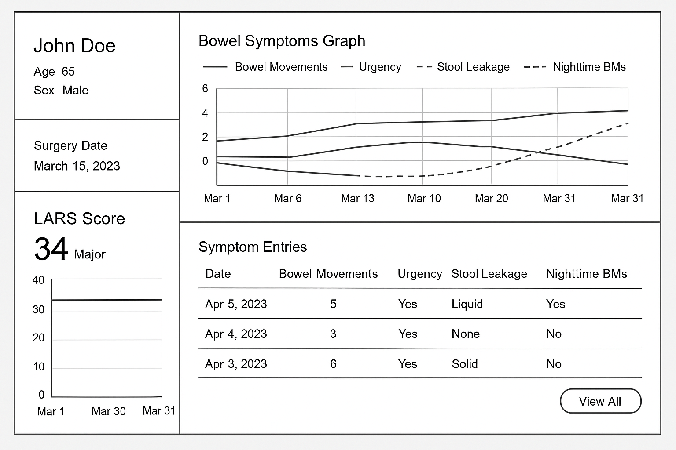

1. Daily Symptom Diary (help with early detection and symptom trend modeling):

|  |  |  |
| --- | --- | --- |
| **Variable** | **Type** | **Input Method** |
| How many bowel movements did you have today? | Free text | Number field |
| Did you experience urgency to defecate today? | Yes/No | Toggle |
| Did you pass stool involuntarily (leakage)? | None / Liquid / Solid / Gas | Multiple choice |
| Did you have nighttime bowel movements? | Yes/No | Toggle |
| Did you feel bloated today? | 0–10 scale | Slider |
| Did you experience incomplete evacuation? | Yes/No | Toggle |
| Did you use any incontinence pads today? | No/Yes + Quantity | Toggle + Number |
| How much did your symptoms interfere with daily activities? | 0–10 | Slider |
| Bristol Stool Type | 1–7 | Selection grid |

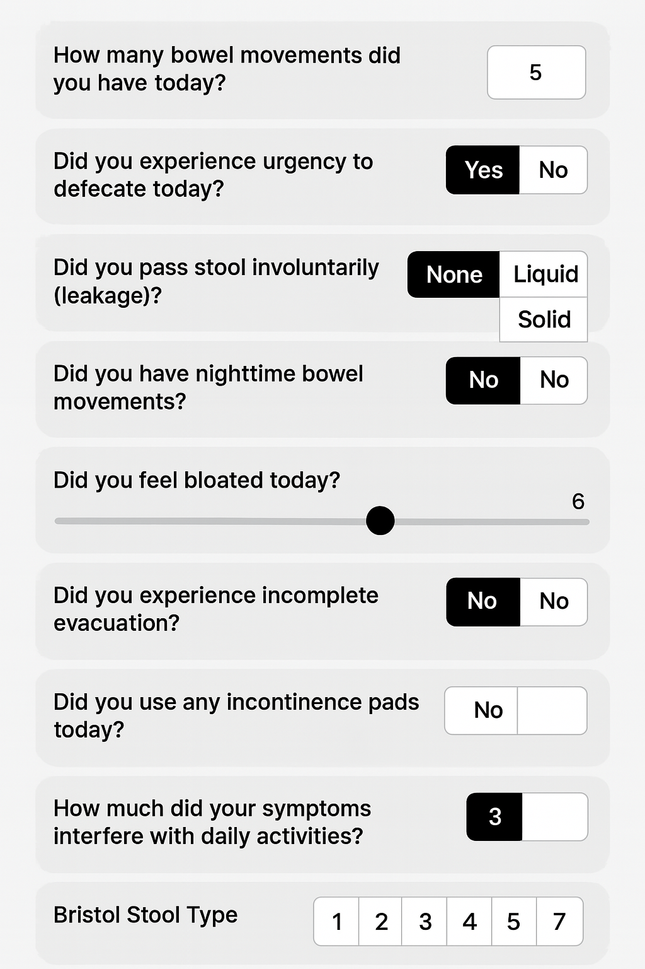Prisegu pvz kaip įsivaizduoju:

2. Optional daily:

|  |  |
| --- | --- |
| **Variable** | **Notes** |
| Daily diet tags | Fiber, dairy, caffeine, spicy food (checkboxes) |
| Stress level (self-reported) | 0–10 scale |
| Step count / activity level | Manual or passive (e.g. via Fitbit or Google Fit/etc) |
| **Medications** used (e.g., loperamide) | Optional dropdown |

1. Weekly LARS Score (include standard 5 LARS variables every 7 days (or auto-calculate based on daily data)):

|  |  |
| --- | --- |
| **Question** | **Input** |
| Bowel frequency | 0–4 / 5–7 / >7 per day |
| Clustering | Never / <1×/week / ≥1×/week / daily |
| Urgency | Never / <1×/week / ≥1×/week / daily |
| Incontinence for flatus | Never / <1×/week / ≥1×/week / daily |
| Incontinence for liquid stool | Never / <1×/week / ≥1×/week / daily |

<https://www.escp.eu.com/images/news_and_reports/2018/lars-scoring-tool/Lithuanian-LARS-Questionnaire.pdf>

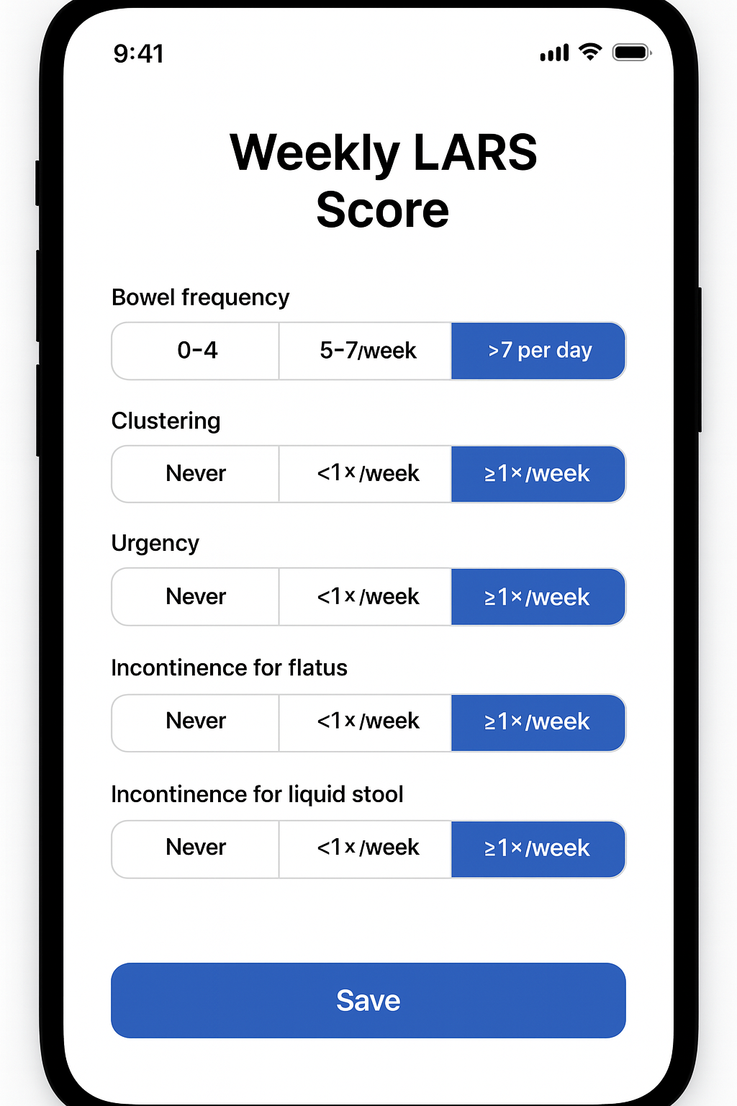

1. Monthly Quality of Life / Emotional Impact (Track how LARS affects social function, confidence, mood)

|  |  |  |
| --- | --- | --- |
| **Variable** | **Source** | **Input** |
| I avoid traveling due to bowel problems | FIQL – Lifestyle | 1–4 Likert |
| I avoid social activities | FIQL | 1–4 Likert |
| I feel embarrassed by my condition | FIQL / CR29 | 1–4 Likert |
| I worry others will notice my symptoms | FIQL / CR29 | 1–4 Likert |
| I feel depressed because of bowel function | FIQL | 1–4 Likert |
| I feel in control of my bowel symptoms | Custom | 0–10 Slider |
| Overall satisfaction with bowel function | Custom | 0–10 Slider |

<https://pubmed.ncbi.nlm.nih.gov/15678208/> Šitam gali reikėti prašyt prieigos/Copyrights, bet jei keičiam ir nenaudojam viso copy-paste, gal ir nereikia – nežinau. Galima būtų rašyt “programėlė parengta remiantis……..”. Jei neklystų, už copyrights Mayo mokėjom apie 130 USD.